Saturday Cooking Club – Doing it Together
October 13th to November 24th (No class Nov 17th)
Ages 8 – 12; 12:15 – 1:30 p.m.
Ages 12 – 21; 1:45 – 3:00 p.m.

Do you enjoy working in the kitchen? Would you like to work with your child to learn some practical kitchen skills while having fun and making friends at the same time?

Join our Saturday cooking club at
St John’s Presbyterian Church – 251 Bannerman

We use the Guided Participation model to facilitate flexible thinking and decision-making while strengthening the parent-child relationship in a supportive environment. Parents who have attended the Flexible Thinking learning series at RCC will have a hands-on opportunity to put strategies into practise. If you have not attended the Flexible Thinking program, you are still welcome to register!

Cooks of all ability levels are welcome. We provide adapted cooking equipment as needed, including switch-operated devices.

To register a spot for you and your child, please complete the attached registration form and forward to Dom (dgagne@rccinc.ca)
- At SSCY reception desk – 1155 Notre Dame Avenue
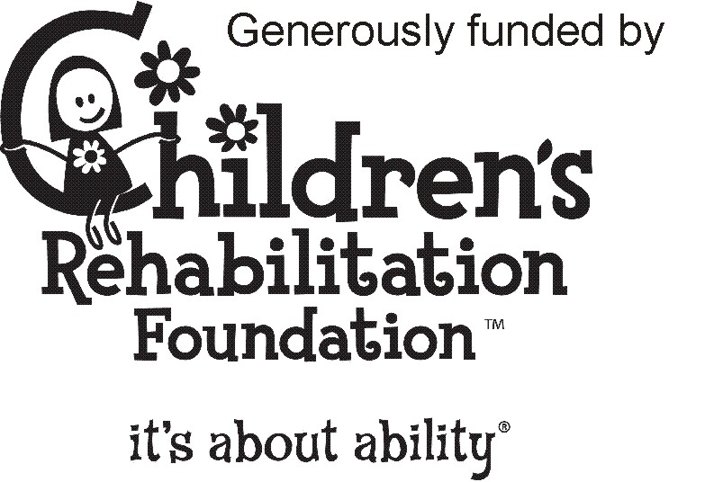
- Fax 204-477-5547
- Mail (1155 Notre Dame Ave, Wpg MB R3E 3G1)

Questions? Call or email:
- Maya – mkirstein@rccinc.ca – 204-258-6538
- Carol – ckehler@rccinc.ca – 204-258-6537

